Enhancing market linkages for rural entrepreneurs through stakeholder engagement
Citizen participation: A Tool for Accountability & Development (CPAD) project being implemented in Buhera district with the aim of addressing low levels of participation of women and youth in governance processes. One of the main activities under the project was facilitating value chain development forums for economic rights. The value chain development forum stemmed from challenges of markets that were cited by farmers during ward based dialogues in various value chains. The platform was aimed at enhancing and strengthening enterprises, business relationships, improving market structures and the business environment. In addition to that, synergies between private and public sector players along key value chains were convened at district level to interrogate opportunities to enhance the efficiency across different value chains and secure commitments from the various actors.
The value chain development platform in Buhera district was convened at Murambinda and various stakeholders from line ministries were invited including private sector companies and the business community. Commitments were made by 2 of the service providers, Montana Meats and National Arts and Handcrafts Center to have follow-up visits to entrepreneurs and enhance market linkages. A follow up visit was conducted with Montana Meats to Cattle fattening groups in the 3 wards. The follow up visits were also accompanied by the Business development officer from the Department of Small and medium enterprises. During the visit, Bangure feedlot members sold 2 of their cattle in their feedlot to Montana meats. Montana meats pledged to provide the feed to the citizens which will be paid back after they sell their cattle. The engagement with Montana resulted in farmers realizing improved incomes from the sale of their cattle at fair prices and conditions.
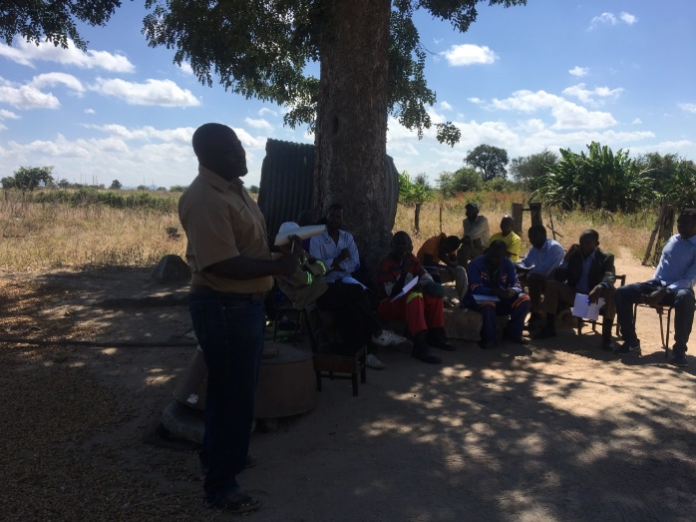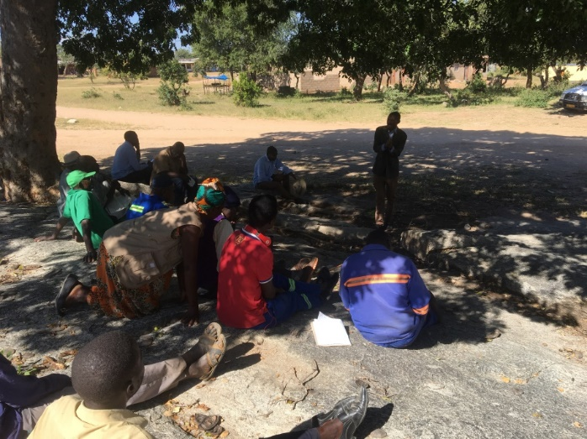Montana meats manager addressing farmers in Buhera SME’s Business development officer addressing farmers in ward 19

