From mere vegetable vendor to GOATS master farmer.
Life has not been easy for 55 year old Alton Dube 55, who is married to Alukile Nyathi 32. The couple has 4 children (all boys) and lives in Mnyabetsi village in ward 17, Bengo of Gwanda district. The couple had dreams to live a better life. Their only source of income was from selling leafy vegetables and tomatoes they grew in their small garden with 20 beds. They were watering the garden using a bucket system. The money they got was not enough as they were to pay school fees for their children as well as buy food.
The two joined Self Help Development Foundation in 2018 and their lives started changing for the better. In SHDF through the Green Enterprise Business Development Programme (GEBDP) they received trainings on financial literacy, savings and Start and improve your business idea generation. The two quickly turned theory in practice as they saved from the vegetable sales and bought 10 female goats for rearing as a business. Alton then attended a training on Goat keeping at Zvikomborero Farms in Chivhu which further sharpened his mind and the zeal to intensify his goat project. To date, Alton has a total of 110 goats, he is now growing vegetables for family up keep and also the feed for his goats which he started on 7 x 10m beds. With his commitment, SHDF further assisted him with a DC pump and Solar panel which he is now using to water his garden as well as pump water for his goats. Alton has now hired one man who is helping with herding the goats and watering the garden.
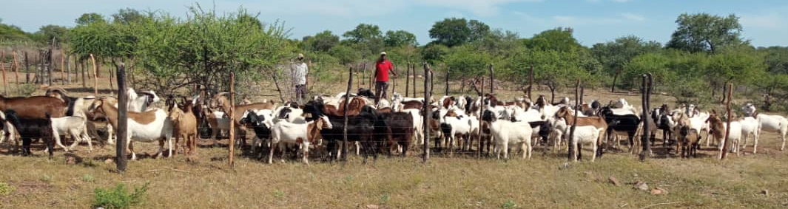
Alton Dube in red, pictured with his goats.
“Bengingazi ukuthi impilo enhle yomuntu ikhona emcabangweni wami.Namhla lami ngiyindoda emadodeni ngoba sengiphila impilo enhle ngilezifuyo ngiyathengisa zingincedise kufees yabantwana. Thank you SHDF because you unveiled the great potential in me” said Alton Dube.
“Ngilokubonga okukhulu ku SHDF ngezifundiso lokusitshengisa ukuthi impilo enhle uyazezela ngalokho olakho.Kuqakathekile ukufusha imali ngoba namhla kusizalele isibaya.Ngiyaziqhenya ngohlelo lwe GEBDP mina ingenzele kuhle.” said Mrs Alukile Nyathi with joy in her face as she praised SHDF for bringing GEBDP in her area which trained them on the importance of savings for investment.
Alton has become a prominent goat farmer in the ward as some villagers from other villages consult him to assist them with their goats. In February 2020, the Embassy of Sweden through the lead partner We Effect, availed funds to lift the confidence of the small farmers which was done as they recorded some learning videos reflecting where they come from which were shared with other members across the nation. As for Alton he has reached about 50 villagers sharing the knowledge on goat keeping. Alton and Alukile were greatly motivated and they expressed much joy and even promised that they want to grow their enterprise until they become well known suppliers of goat meat and goats for breeding to NGOs and surrounding communities,

