Value Chain Development Platform Unleashes Employment Opportunities for youth
Youth unemployment in Zimbabwe has reached alarming rates leaving them to find solace in roaming up and down local townships and engaging in illegal activities like drug abuse. The story is different for Caston Gundumure, a male youth from ward 32 Buhera district. Caston has shown resilience and commitment in developing life skills for the betterment of his life and that of his peers. Caston joined SHDF in 2017 when he had just finished his O’ Level and was not doing anything. In SHDF, Caston participated in various trainings which include constitutional literacy, waste management and citizen journalism. Since becoming a members of the organisation Caston has been an active development actor in his ward and has been a serial participant of SHDF activities.
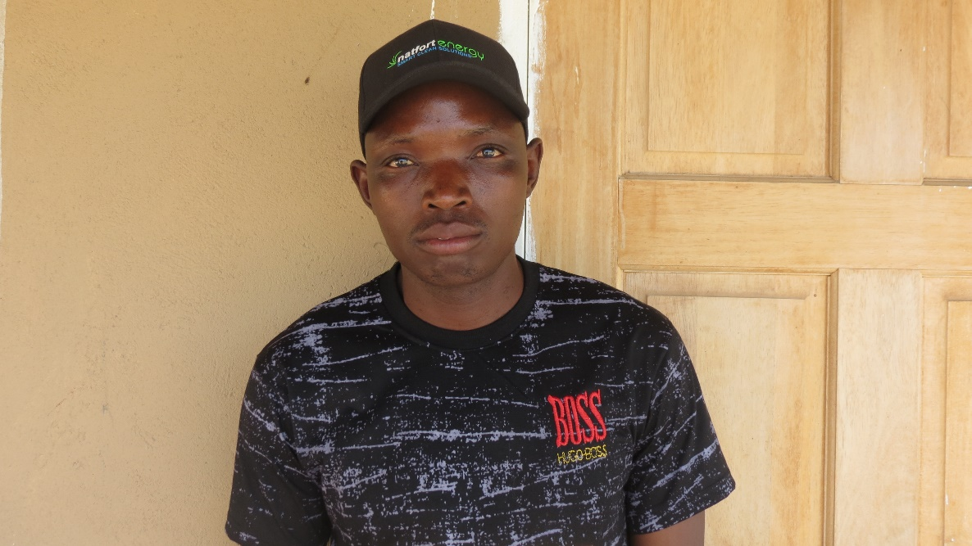
Recently, SHDF organized a Value Chain Development Platform in Buhera district which brought together different value chain players and rights holders to deliberate on key value chain issues that affected them. On this platform, Natfort Energy a private company which specializes in smart and renewable energy committed to hire youth from the district as solar installation agents. Caston, who was also present at this event was engaged by the company to be a solar installation agent and to sell solar products on behalf of the company at a commission. Just like my fellow youth in the district, I used to mock SHDF engagements but now my life has changed. Many youth believe in handouts and are still and still shy away from participating in developmental activities being carried out in the district. I have become a household name because of the work that I do in the communities. Besides, I am now earning decent income and I am looking forward to a brighter future. I am grateful to SHDF for the value chain platform that has transformed my life, said a cheerful Caston.
Caston Gundumure

